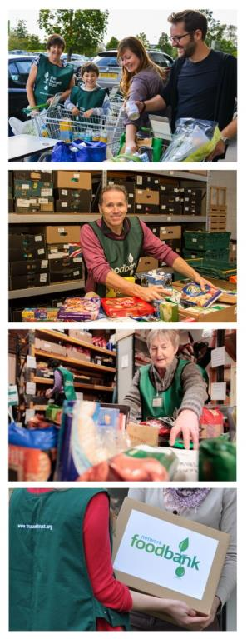

**Contact**

Telephone 0114 2530315

Email: info@gleadlessvalley.foodbank.org.uk

Website : gleadlessvalley.foodbank.org.uk

**The Gleadless Valley Foodbank**

Gleadless valley Methodist Church

Blackstock Road

Sheffield S14 1FT

Charity Number: 1154619 Registered in England & Wales/Scotland

**About Gleadless Valley foodbank**

The Gleadless Valley foodbank opened in October 2011 to give people in crisis hope, practical help, and a brighter future. We value all of our supporters who make a big difference.

We provide three days’ emergency food and support to local men, women and children in crisis in our area. Our vision is to ensure that no-one in our community has to go hungry.

**Food Donations**

All of our food is generously donated by people in the local community (schools, businesses, churches and individuals) and volunteers of all backgrounds help to sort, pack, and distribute food parcels to individuals and families in need. Local people are feeding local people.

**Frontline Care Professionals**

The families and individuals who come to us have been referred by care professionals. Social workers, health visitors, school liaison officers and others, work with us to help people in crisis so that they do not have to go hungry.

**Join the 200 Club and help local people in crisis**

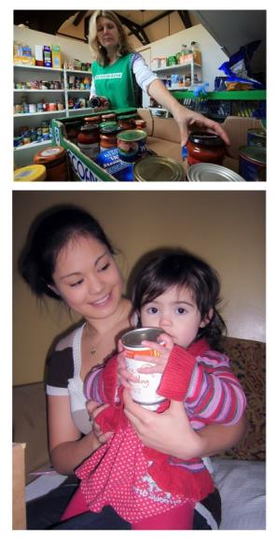

**Standing Order Mandate**

**gleadlessvalley.foodbank.org.uk**

**Could you partner with {Named} foodbank and join the 200 Club?**

We appreciate all the different ways that people support The Gleadless Valley foodbank, from donating food to volunteering, holding fundraising events, and one-off gifts.

Another amazing way of supporting us is to commit to our 200 Club.

**Could you be one of 200 people to commit £5 a month or more to support our work?**

Your regular giving will provide emergency food and support local people in crisis.

It will also help us to budget effectively and demonstrate to other potential funders that our foodbank is sustainable.

**Donate to The Gleadless Valley foodbank**

Find out about the different ways to donate on our website or simply fill in the form on the next page and we’ll do the rest!

[www.gleadlessvalley.foodbank.org.uk](http://www.gleadlessvalley.foodbank.org.uk)

If you are a UK tax payer, we can also claim an extra 25p with every £1 you donate at no extra cost to you.

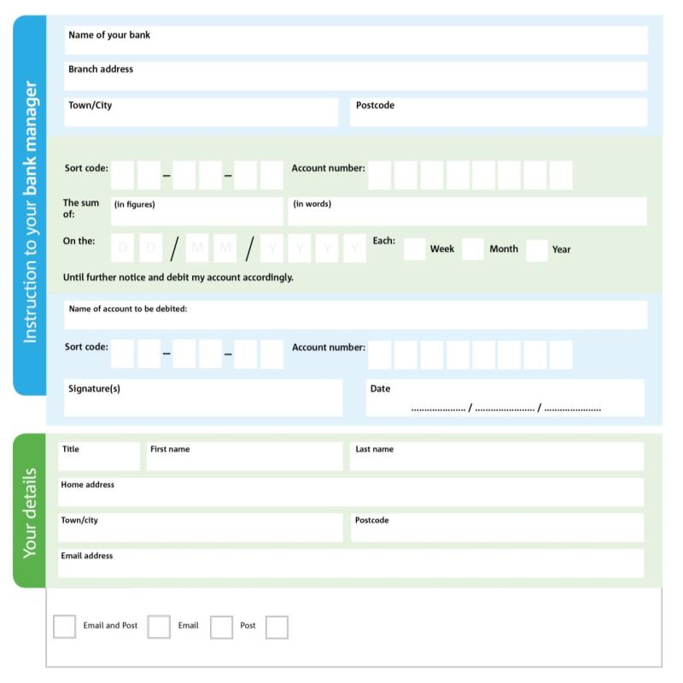

Please pay Gleadless Valley Foodbank

X X X X X X X X X X X X X X

We would love to keep you up to date with information about Gleadless Valley Foodbank. Please tick your preference:

I do not wish to receive future communications from Gleadless Valley Foodbank

You can change your preferences any time by contacting us on 0114 2530315or emailing us atinfo@gleadlessvalley.foodbank.org.uk

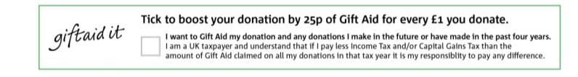

I do not wish to receive future communications from XXXX Foodbank

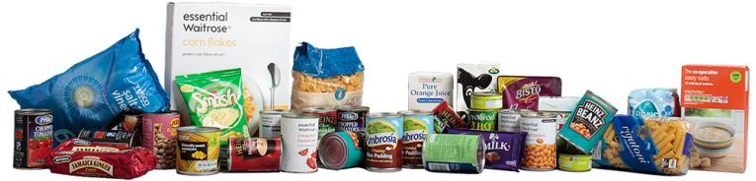

**Data protection**

*'The Gleadless Valley Foodbank is committed to protecting your privacy and will process your personal data in accordance with current Data Protection legislation. The Gleadless Valley Foodbank collects information to keep in touch with you and supply you with information relating to our work. To unsubscribe from our newsletter, send a message to the email address above with the word unsubscribe in the subject line. A full data privacy statement for financial donors is available from the foodbank on request.’*

**Please pass this form onto the foodbank, using the foodbank’s address at the bottom, who will save a copy for their records. They will then send it onto your named bank or building society.**